ID: 27377

Name: Vinay Kumar G

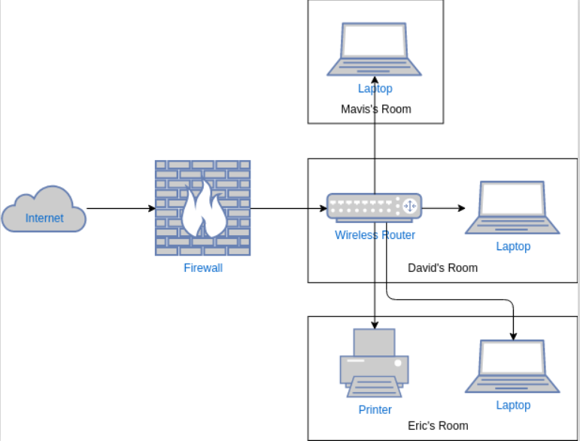

1. **Internet** - In a home network topology, the internet is the external global network that connects your devices to the world (websites, online services, apps, etc.). It comes into your home through an Internet Service Provider (ISP) and is distributed to your devices through a router (wired or wireless).

2. **Firewall** - a firewall is a security system that monitors and controls incoming and outgoing network traffic based on predefined security rules. It acts like a gatekeeper between your home network and the internet, protecting your devices from unauthorized access, malware, and cyberattacks.

3. **Wireless routing** is the process of using a Wi-Fi router to send data wirelessly between devices (laptops, phones, printers, etc.) and the internet within a home network. It allows devices in different rooms to be part of the same wireless network.

**How the Connection Works**

In our home network setup, the wireless router, which is placed in David’s room, acts as the central hub — essentially the brain of the network. It is connected to the internet either through a modem or has a built-in connection, and it broadcasts Wi-Fi signals across the house. All devices, including laptops and a wireless printer, connect to this router using Wi-Fi, forming a star topology where the router is at the center. For example, David’s laptop connects at a short range, while Marvis’ and Eric’s laptops, as well as Eric’s wireless printer, all connect to the same Wi-Fi network. This setup allows all devices to communicate through the router. So, if Marvis wants to send a document to Eric’s printer, the data first goes to the router, which then forwards it to the printer. Similarly, Eric’s laptop can access his wireless printer via the router, and all laptops can browse the internet through this central connection point. The router manages all data traffic between devices and with the internet, ensuring smooth and centralized communication.